  - NAD Electronics Announces the C 389 HybridDigital DAC Amplifier
Latest integrated amplifier reinforces NAD’s core values of performance, flexibility, and value
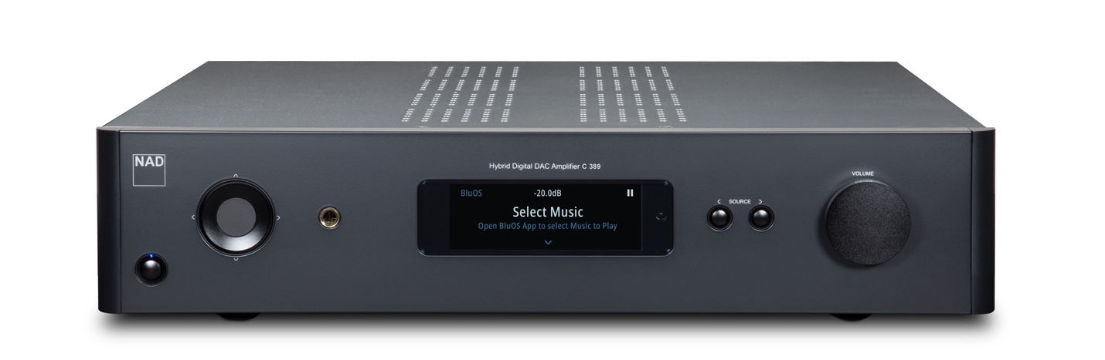
NAD C 389 from front

Munich High End, Munich, Germany, May 17, 2022 – NAD Electronics, the highly regarded manufacturer of high-performance audio/video components, today announced the C 389 HybridDigital DAC amplifier, the perfect cornerstone for an audiophile-grade stereo system combining exceptional sound quality with the flexibility and the long-term value offered by NAD's latest Modular Design Construction platform, MDC2. Available for retail sale in early Summer 2022, the C 389 will carry a suggested retail price of $1,499
US / £1,299 GBP / €1,499 EUR.

Featuring NAD’s proven HybridDigital UcD amplifier design and the same ESS Sabre DAC used in the brand’s up-market Masters Series amplifiers, the C 389 has been engineered to deliver thrilling dynamics and transparent, detailed sound. The digital section is built around a 32-bit/384kHz ESS Technology Sabre DAC chip renowned for its near-zero levels of clock jitter, exceptionally wide dynamic range, and ultra-low noise and distortion, delivering astonishing clarity and holographic imaging on all sources.

For the output stage, the C 389 uses a customized version of NAD’s HybridDigital UcD design, with multiple UcD amplifier modules in balanced bridged configuration and an innovative switch-mode power supply that can provide ample reserves of current on demand. Delivering 130 Watts per channel of continuous power, the C 389 can produce real-life listening levels with any loudspeaker load, with virtually unmeasurable distortion and noise through the audioband, and effortless reproduction of musical transients.

With a full suite of digital and analogue inputs, including an ultra-low-noise phono stage and HDMI eARC interface, the C 389 can accommodate all your source components. In addition to two sets of speaker outputs, the C 389 has two subwoofer outputs, preamp outputs, and a dedicated headphone amp.

The C 389 incorporates the latest iteration of NAD’s Modular Design Construction technology, MDC 2, and with its two MDC2 expansion slots, the C 389 can adapt to technical advances and evolving user needs. Introduced in 2006, NAD’s Modular Design Construction future-proofing technology lets owners of MDC-capable components add new capabilities by inserting an expansion module into an MDC slot on the rear panel. Introduced in 2021, MDC2 is an all-new design that allows two-way communications between the expansion module and host component. NAD’s first MDC2 module is the MDC2 BluOS-D, which features BluOS high-res multi-room streaming and Dirac Live room correction.

The MDC2 BluOS-D connects to your home network via Wi-Fi or wired Ethernet. With the MDC2 BluOS-D installed, the C 389 can be part of a whole-home music system with as many as 64 zones. Controlled via the BluOS Controller app, available for Android, iOS, macOS, and Windows, listeners can play music from over 20 streaming services including Tidal, Deezer, Qobuz, Amazon Music HD, or Spotify, or from their personal music libraries. Like all BluOS-enabled components, the MDC2 BluOS-D will bring MQA decoding and rendering capability to the C 389, as well Apple AirPlay 2 and control by popular voice assistants. Connect the supplied microphone to the MDC BluOS-D’s USB port, and then run the free Dirac Live app on a smart device or personal computer. Dirac Live room correction compensates for acoustic problems like standing waves and room reflections. The results are transformative and offers deeper, more textured bass; more precise imaging; and improved timbral accuracy.

Key Features
- Customized HybridDigital UcD amplifier in fully balanced bridged configuration
- Continuous Power: 2 x 130 Watts per channel into 8/4 ohms (preliminary)
- Instantaneous Power: 210 W into 8 ohms, 300 W into 4 ohms, 350 W into 2 ohms (preliminary)
- Vanishingly low harmonic and intermodulation distortion
- Nearly unmeasurable noise through the entire audioband
- Dual MDC2 ports for expanded functionality
- Optional MDC2 BluOS-D module adds BluOS Hi-Res multi-room music streaming and Dirac Live room correction
- Jitter-free 32-bit/384kHz ESS Sabre DAC
- Ultra-low-noise MM phono stage with infrasonic filtering circuitry
- Two optical, two coaxial digital inputs
- HDMI-eARC input
- Two pairs of line-level analogue inputs with ultra-low-noise buffer amplifiers
- Speaker A/Speaker B outputs
- Two-way Qualcomm aptX HD Bluetooth
- Dual subwoofer outputs
- Dedicated headphone amplifier
- CI-Friendly - IR remote, 12V Trigger in/out, IR in/out, RS-232 Serial port
- Seamless integrations with smarthome control systems such as Control4, Crestron, RTI, URC, Lutron, and Elan

About NAD Electronics
Founded in 1972 and now sold in over 80 countries, NAD Electronics is renowned for its
award-winning line of high-quality components for audio, home theatre and custom
installation applications. Since the beginning, NAD’s commitment to four core values –
innovation, innovation, simplicity, performance, and value – have earned it a cult-like
following that catapulted it to becoming a household name amongst audiophiles and
music lovers alike. To this day, the brand continues to design and manufacture some of
the most acclaimed and affordable hi-fi components that include modern features and
technologies meant to appeal to a new generation of audiophiles.

contacts

Corporate Contact
June Ip
Marketing
media@nadelectronics.com

Links
Website: https://nadelectronics.com
Images: https://brandlibrary.lenbrook.com/portals/nadelectronics
Facebook: https://www.facebook.com/nadelectronics
Twitter: https://twitter.com/NADElectronics
Instagram: https://www.instagram.com/nadelectronics/

# # #

